

**Trimester: II Subject: Programming and Problem Solving**

**Name**: Krishnaraj Thadesar **Division:** 9

**Roll No.:** 109054 **Batch:** I3

**Experiment No.:** 3

**Name of the Experiment:** Menu Driven Program using Switch in C

**Performed on:** 23nd December 2021

**Submitted on:** 30th December 2021

**AIM**: Write a menu driven program in C to implement the basic arithmetic operations.

**OBJECTIVE**:

1. To learn and understand operators in C
2. To learn and understand switch case statement.

**THEORY**:

An arithmetic operator performs mathematical operations such as addition, subtraction, multiplication, division etc on numerical values (constants and variables).

*Switch case statement* evaluates a given expression and based on the evaluated value (matching a certain condition), it executes the statements associated with it. Basically, it is used to perform different actions based on different conditions(cases).

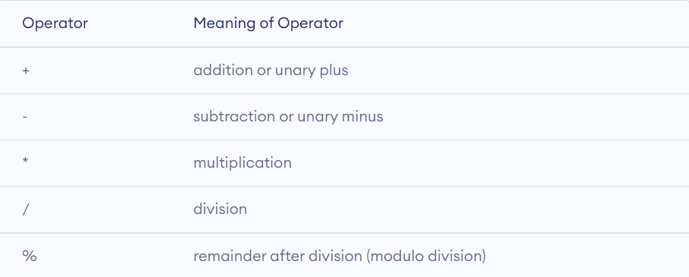

Switch case statements follow a selection-control mechanism and allow a value to change control of execution. They are a substitute for long if statements that compare a variable to several integral values. The switch statement is a multiway branch statement. It provides an easy way to dispatch execution to different parts of code based on the value of the expression.

**SYNTAX**

switch (n)

{

case 1: // code to be executed if n = 1;

break;

case 2: // code to be executed if n = 2;

break;

default: // code to be executed if n doesn't match any cases

}

Some important keywords:

1) **Break**: This keyword is used to stop the execution inside a switch block. It helps to terminate the switch block and break out of it.

2) **Default**: This keyword is used to specify the set of statements to execute if there is no case match.

**Platform**: 64 Bit Windows 11

**Technology**: Visual Studio Code with Mingw-w64 compiler

# ALGORITHM:

Step 1: Start

Step 2: Declare Variables

Step 3: Take Input for First and Second Number from user.

Step 4: Provide Choice to user and take input of which operation to perform

Step 5: Switch Case the choice variable and perform the respective chosen operation.

Step 6: Output the Answer.

Step 7: End

# FLOWCHART:

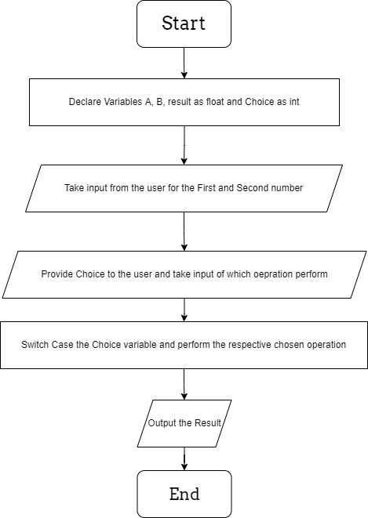

**INPUT**: Any 2 numbers: 20, 4, and choice for operation to be performed

**OUTPUT**: if choice is 1: Addition is=24, if choice is 2: Subtraction is=16.

Code:

*// Program to make a simple menu driven calculator using Switch Case.*

#include <stdio.h>

int main()

{

    float A = 0, B = 0, result = 0;

    int choice = 0;

    printf("Enter First Number: ");

    scanf("%f", &A);

    printf("Enter Second Number: ");

    scanf("%f", &B);

    printf("What do you want to do? \n\

            1. Add\n\

            2. Subtract \n\

            3. Multiply \n\

            4. Divide \n\

    Please Enter (1, 2, 3 or 4): ");

    scanf("%d", &choice);

    switch (choice)

    {

    case 1:

        result = A + B;

        break;

    case 2:

        result = A - B;

        break;

    case 3:

        result = A * B;

        break;

    case 4:

        result = A / B;

        break;

    default:

        printf("Invalid Choice. Please Try again");

    }

    printf("The Result is: %f", result);

    return 0;

}

**Working**:

Addition

Enter First Number: 20

Enter Second Number: 4

What do you want to do?

            1. Add

            2. Subtract

            3. Multiply

            4. Divide

    Please Enter (1, 2, 3 or 4): 1

The Result is: 24.000000

Subtraction

Enter First Number: 20

Enter Second Number: 4

What do you want to do?

            1. Add

            2. Subtract

            3. Multiply

            4. Divide

    Please Enter (1, 2, 3 or 4): 2

The Result is: 16.000000

Multiplication

Enter First Number: 20

Enter Second Number: 4

What do you want to do?

            1. Add

            2. Subtract

            3. Multiply

            4. Divide

    Please Enter (1, 2, 3 or 4): 3

The Result is: 80.000000

Division

Enter First Number: 20

Enter Second Number: 4

What do you want to do?

            1. Add

            2. Subtract

            3. Multiply

            4. Divide

    Please Enter (1, 2, 3 or 4): 4

The Result is: 5.000000

**CONCLUSION**: Thus implemented the basic arithmetic calculator using switch case statement.

**FAQ**:

1. What is break statement?

A break statement terminates the execution of the nearest enclosing for switch, or while statements in which it appears.

1. It can be used to terminate a case in the switch statement
2. It can be used to immediately terminate the iteration of the loop when encountered in a loop. The Program control then resumes at the next statement following the loop.
3. Is case is the keyword?

‘case’ is a keyword in C. It has predefined meaning and thus cannot be used as a variable, but only as a specific predefined notation in the switch control statement.

1. Why to write default case?

In case an unexpected value is encountered for the switched variable, the program control goes to the default case where one can safely handle such exceptions. Were it not for the default case, any unexpected value would be unaccounted for.